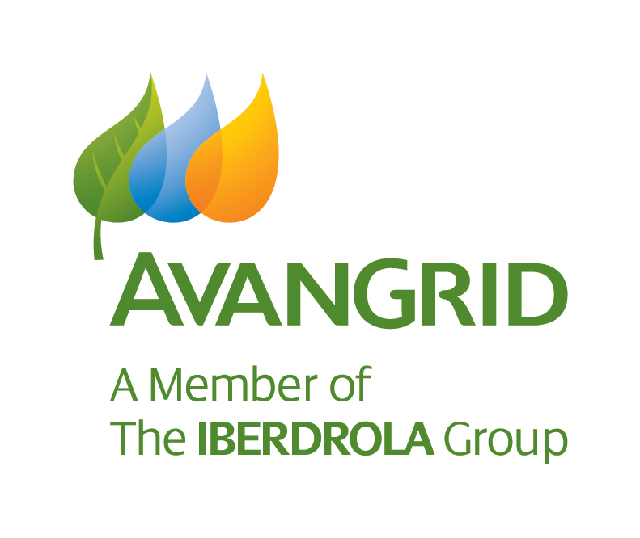

**Community Sponsorship Application**

**Use this form for requests of $3,000 or less**

Before completing this form, please read the Community Sponsorship Guidelines by following this link:  
[Renewables in your community - Avangrid](https://www.avangrid.com/aboutus/renewables/whoweserve/renewablesinyourcommunity#:~:text=Community%20Sponsorship,local%20communities%20and%20their%20activities.)  
or found on the internet here: <https://www.avangrid.com/aboutus/renewables/whoweserve/renewablesinyourcommunity#:~:text=Community%20Sponsorship,local%20communities%20and%20their%20activities>.

Start date of application: Click and select arrow at right to pick application date.

**Employee Advocating for Sponsorship:** *(This section is to be completed by* ***Avangrid employee****.)*

Employee advocating on behalf of applicant:  
Name: Click-enter employee name Employee Number: Click-enter employee # Employee Phone: Click-enter phone#

Your business unit:  Onshore Business  Offshore Business Other: Click here to enter text

Your plant/site code and name: Click and select arrow at right to pick your Plant Code & Name

If approved, will you or someone in your family directly benefit from this sponsorship? Click-Yes or No

If yes, please explain: Click or tap here to enter text.

**Non-Profit Applicant Organization:** *(This section is to be completed by the* ***Applicant Organization Representative****.)*

Legal Name of Organization (as shown on W-9): Click here to enter organization’s name.  
  
Tax Identification Number: Click here to enter Tax ID Number.

Attach Current W-9  Attach Federal IRS Determination Letter as 501(c)(3) Proof

Affiliations (International, National, Regional, Local): Click here to enter affiliations.

Applicant Organization’s (or affiliated parent organization’s) website (or attach brochure):  
Click here to enter your organization’s website, or your affiliated parent organization’s website, or N/A.

Organization’s contact person/representative: Click here to enter contact person’s name.

Contact’s title/role in Applicant Organization: Click here to enter contact person’s title.

Telephone: Click here to enter phone number. Cell: Click here to enter cell phone number.

Email address: Click here to enter email.

Please provide your organization’s mission and a brief description of *your organization’s history, goals and how it contributes to your community* (maximum 300 words, attach a separate page if necessary):

Click here to enter organization’s *history, goals, & contributions to community*.

**Proposed Sponsorship Description:**

**OPTION 1: Specific Fundraising Project/Event**

Name of Project/Event: Click here to enter project/event name.

On what date(s) does your project/event begin and end? Click here to enter date(s).

Briefly describe details of your project/event:  
(If for a project, include materials costs, etc. If for an event, include promotional materials.)  
Click here describe your project.

**OPTION 2: General Program/Operations Support**

Name of Program/Operation:

1. General Support
2. Specific Area of Operations Support  
   Click here to describe focused area of operations support.

**For option 1 & 2 above, complete the following:**

What is/are the objective(s) of the sponsorship:  
Click here to enter objectives.

What is the forecasted size of the sponsorship’s impact:  
(Number of participants, visitors, meals provided, persons assisted, funds to be raised, other quantifiable measure?)  
Click here to enter expected numbers to be impacted by the sponsorship.

Tell us how this contribution may benefit underserved/underrepresented population groups and promote diversity, equity and inclusion:  
Click here to enter Diversity Equity &Inclusion impact goal.

What other organizations are you asking to partner with in support of this sponsorship:  
Click here to enter other potential partners.

How would you characterize the nature of this sponsorship?

*(Refer to the Sponsorship Guidelines at the web address listed on page 1.)*

|  |  |
| --- | --- |
| Arts and Culture | Environment/Sustainable Energy |
| Health, Education, Social Services, and Youth Activities | |
| Economic and Community Development | Emergency Relief |
| Other (please specify): Click here to specify. | |

Does your organization have a social media presence we can cite? If so, please tag Avangrid as follows to invoke our company:

@Avangrid on X (Twitter) - <https://x.com/Avangrid>

Avangrid on Facebook - <https://www.facebook.com/Avangrid/>

@Avangrid on Instagram - <https://www.instagram.com/avangrid/>

Avangrid on LinkedIn - <https://www.linkedin.com/company/avangrid/>

@Avangrid on YouTube - <https://www.youtube.com/@Avangrid>

|  |  |  |  |
| --- | --- | --- | --- |
| Facebook | Click to enter your handle. | X (Twitter) | Click to enter your handle. |
| Instagram | Click to enter your handle. | Other | Click to enter your handle. |

Do you plan to use our company name or logo outside of social media to publicly recognize and/or acknowledge our support of this project or event?  
(Any use of our company name or logo requires review & approval, email Community@avangrid.com.)  
 No  
 Yes (Attach a draft for review if available & advise your Media/PR/Communications contact’s details.)  
Your Media/PR/Communication contact: Click here to enter Media/PR contact’s details.  
 Newspaper/Radio/TV  
 Website  
 Newsletter/Brochures  
 Signs/Ads  
 Emails  
 Other (please specify) Click here to enter other avenues of acknowledgement.

Does your organization have any of the following circumstances to disclose?  
 Organization or affiliate engages in political campaigns  
 Contribution is related to business conducted by or other benefit received by Avangrid Renewables  
 Organization or related director/manager has been implicated in corrupt or illegal activity in the past 5 years  
 Organization’s activities occur outside of the US  
 Organization’s manager/director or closely related person is employed by Avangrid Renewables or   
 Avangrid Renewables’ vendor  
 Organization is associated with US or foreign public official or person closely related to an official  
 Other potential reputational or compliance risk (please specify) Click here to enter other potential risk.  
 None of the above and no other potential reputational or compliance risk.

Disclosures are referred to Avangrid’s Compliance Division prior to application evaluation.

Proposed monetary sponsorship: Click here to enter funding request.

Proposed volunteer opportunity for Avangrid employees:  
(Number of volunteers? Number of hours each employee? Special skills/equipment required?)  
Click here to enter service description, if any.

**Terms of Agreement:**

*In connection with Avangrid’s sponsorship of your request, we ask for your consent below.*

*I, on behalf of the organization listed above, understand and agree that by accepting a sponsorship from Avangrid that I have the authority to submit this application and bind the organization to this consent. The organization will cooperate with the company as needed to fulfill its corporate social responsibility reporting and publicity requirements in accordance with its corporate parent organization Avangrid Inc. The applicant organization also understands and agrees that by accepting a sponsorship from Avangrid that any uses of the company name or logo must comply with corporate brand standards and that the company may use the name of the organization in its promotions, marketing materials and social media channels. Furthermore, the organization agrees that it will use the funds, if any, given by the company for the express purpose identified in this application and for no other purposes. The organization further acknowledges that the company, in its sole discretion, may decide not to fund any of the requested amounts or services to the organization.*

*Please send logo/brand-related questions to Community@avangrid.com.*

**\*\*Applicant Organization must provide IRS Determination Letter & a current W-9 with every application.\*\***

Signature of Applicant Organization Authorized Representative:

_______________________________________________________________________  
Click to print name here.

Date: _____________________

**How to submit the completed application:**

Please email your completed Community Sponsorship Application, the required IRS W-9 and IRS Determination Letter as 501(c)(3) proof, to [Community@avangrid.com](mailto:Community@avangrid.com).

Rev 2025Jan15