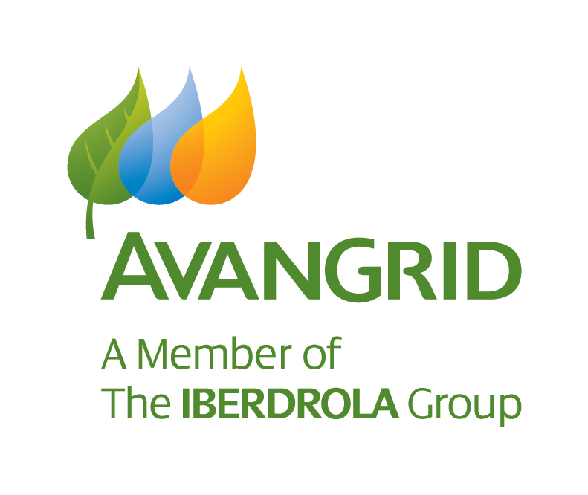**Community Sponsorship Guidelines**

**PURPOSE:** Avangrid Renewables, LLC, works hard to earn the trust and respect of the communities where we do business. The Community Sponsorship Guidelines set out parameters for where and how the company may make selective sponsorships or company-sanctioned employee volunteer hours in support of local communities.

**SCOPE:** This policy covers sponsorships on behalf of the Avangrid Renewables, LLC, and Klamath Energy.

**POLICY OWNER:** Avangrid Renewables, Policy, Regulation and Markets. Questions should be directed to [community@avangrid.com.](mailto:community@avangrid.com)

# POLICY:

* 1. **Sponsorship Types and Availability**

Sponsorships may consist of monetary contributions of Avangrid Renewables’ employee’s time and skill as volunteer hours. The form and value of the sponsorship are at the discretion of the company.

# To be considered, proposed sponsorships should generally fall into one of the following categories:

* + 1. **Arts & Culture** - such as sponsorships of concerts, county fairs, museums, rodeos, theaters, local festivals.
    2. **Environment/Sustainable Energy** - such as community educational programs, Earth Day events, and other activities to strengthen conservation and environmental awareness.
    3. **Cooperation & Solidarity -** including:

**Health** - such as contributing to local hospitals for equipment, facility upgrades, health fairs, and medical research and patient support.

**Social Welfare** - such as food pantry funding, holiday gifts for homeless children, and other appropriate activities.

**Education and Young People** - such as the purchase of kits and volunteering to help build-and-design-your-own-wind-turbines, student competitions involving renewable energy, scholarships including for community college wind technician training, science lab equipment, and the purchase of school safety equipment.

* + 1. **Economic Development** - such as support for development or improvement of community parks, gardens, or meeting facilities.
    2. **Emergency Relief** - such as blood drives, home heating for low-income households, aid for fire and emergency-response services, and disaster assistance.
    3. **Other Sponsorships** - including sports booster clubs and little leagues in the communities that host one or more of the company’s operating facilities, community endowment funds that support multiple local charities, etc.
  1. To be considered, sponsorship opportunities must be in the vicinity of a community where the company does business.
  2. Amounts available for Community Sponsorships are solely at the discretion of the company. For information on the range of likely grant amounts currently available, contact community@avangrid.com.

# 2.0 Employee Advocate

Each application for a Community Sponsorship must be made in association with an employee advocate of an Avangrid Renewables, LLC, business entity. That employee will act as liaison between the company and the Applicant Organization and will act as a single-point-of-contact for those within the company evaluating the request. Any application without an employee advocate will be considered incomplete as described in 3.1 below.

# Application and Decision-Making Process

* 1. To be considered for a donation, a completed **Avangrid Renewables, LLC, Community Sponsorship Application** must be submitted in the manner noted on the application form. Incomplete forms will not be accepted. Applications deemed incomplete may be re-submitted.
  2. Sponsorship applications will only be accepted for entities organized under Section 501(c)(3) of the Internal Revenue Code and local governments where a related organization with 501(c)(3) status is not established and may not support political or religious organizations and activities.
  3. Each corporate office application will be reviewed and acted on by a Contributions Committee which is appointed by the CEO and convened by the head of Policy, Regulation and Markets.
  4. Each application for the area of an operating asset will be forwarded to the relevant plant manager for review and action. In reviewing an application, the plant manager shall consult with other relevant departments as appropriate.
  5. Application funding decisions will be communicated to the Employee Advocate and Applicant Organization by Policy, Regulation and Markets.
  6. Policy, Regulation and Markets is responsible for processing, accounting, tracking and monitoring all applications.

# 4.0 Corporate Reporting and Publicity

The Applicant Organization understands and agrees that by accepting a sponsorship from Avangrid Renewables, LLC, the applicant will cooperate with the company as needed to fulfill its corporate social responsibility reporting and external publicity requirements in accordance with its corporate parent organization Avangrid Incorporated. These efforts may extend beyond the time of the applicant’s actual event or project.

**5.0** **Branding**

Many sponsorships include the opportunity to display the company name and/or logo. The Applicant Organization agrees that by accepting sponsorship support from Avangrid Renewables, LLC, that any uses of the company name or logo must be pre-approved by Avangrid, to comply with the company’s international brand requirements. All such inquiries must be directed to [community@avangrid.com](mailto:community@avangrid.com). **Failure to comply can result in forfeiture of sponsorship monies.**

Updated: 2025Jan15